**Assignment** -2

Build a phyton code, Assume u get temperature and humidity values (generated with random function to a variable) and write a condition to continuously detect alarm in case of high temperature.

Code:

int gasSensor=A1;

int buzzer=13;

int led=12;

void setup()

{

temperature_feed =('temperature')

humidity_feed =('humidity')

pinMode(A1,INPUT);

pinMode(buzzer,OUTPUT);

pinMode(led,OUTPUT);

Serial.begin(9600);

}

void loop()

{

int sensorValue=analogRead(gasSensor);

Serial.print("GAS LEVEL:");

Serial.println(sensorValue);

delay(1000);

if (sensorValue>250)

{

digitalWrite(buzzer,HIGH);

digitalWrite(led,HIGH);

}

else

{

digitalWrite(buzzer,LOW);

digitalWrite(led,LOW);

}

}

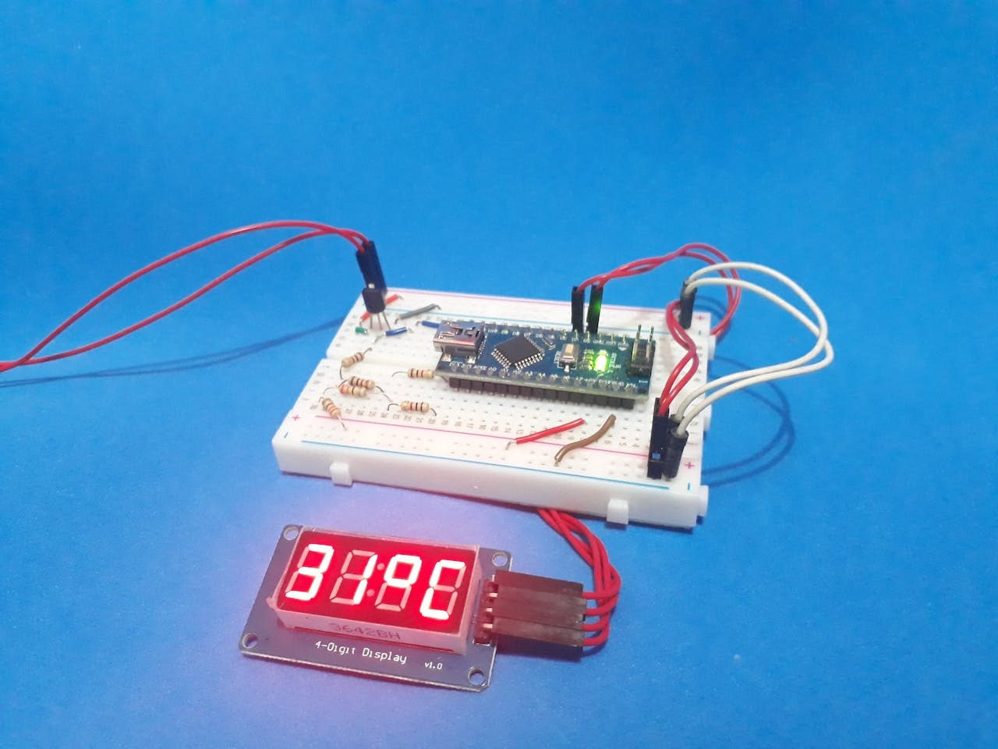

Submitted by,

Amarjith

Arun kumar

Deepak

Joyal Prasanna